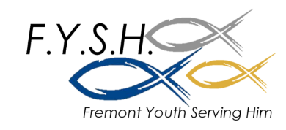
Fall 2020 Schedule

Date | Series | Title/Topic
Sept 13 | FYSH Community –  BOY Kick Off | Beginning of the Year Party
Sept 20 | FYSH Bible –  Jude | Jude: 1-4 “Beloved”
Sept 27 | FYSH Community –  Small Group Night | Boy/Girls Pick adventure and location
Oct 4 | FYSH Bible –  Jude | Jude 5-11 “Delivered”
Oct 11 | FYSH Community – Heritage Farms | Meet us as Heritage Farms – Rides could be arranged
Oct 18 | FYSH Bible –  Jude | Jude 12-16 “Pretenders”
Oct 25 | NO FYSH –  CEA Convention
Nov 1 | FYSH Community –  Small Group Night | Boy/Girls Pick adventure
Nov 8 | FYSH Bible –  Jude | Jude 17-23 “Perseverance”
Nov 15 | FYSH Community –  Small Group Night | Boy/Girls Pick adventure
Nov 22 | FYSH Bible –  Jude | Jude 24-25 “Doxology”
Nov 29 | NO FYSH – Thanksgiving Break
Dec 6 | FYSH Bible –  Jude | Jude Wrap up “Immanuel”
Dec 13 | FYSH Community – Christmas Part | Branstrom Sledding Party
Dec 20 | NO FYSH –  Christmas Break

*Events highlighted in yellow will be outside. These events, with exception of the heritage farms event and the small group night, will be at Zach Van Wyk’s house. (5856 S Green Ave, Fremont)

